DVR 升级步骤( upgrade manually）

- 将升级文件复制到U盘，然后将U盘插在DVR的USB接口上。
Save the upgrade files in the USB drivers .

- 进入DVR的主菜单，选择高级设置。
Entered mainmenu and choose the Advance Option.

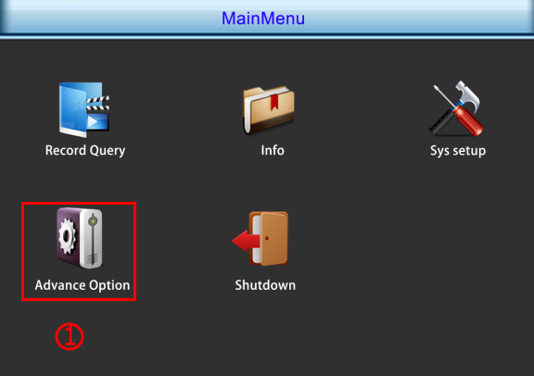

- 进入高级设置，选择升级。
Entered Advance Option choose the Upgrade.

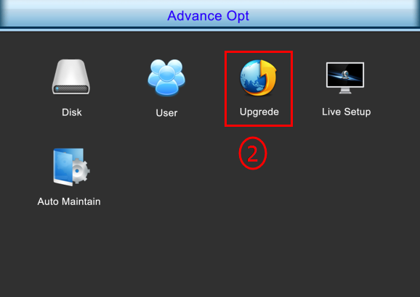

4.选择升级文件后，点击升级。升级过程中不能断电、拔掉U盘，否则DVR会死机。
Choose the upgrade files and click upgrade. When upgrading can’t cut off the power and remove the USB drivers.

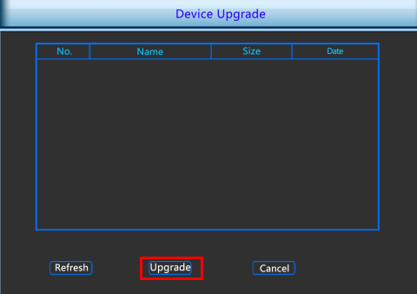
- 当升级完成，DVR自动重启时将U盘从DVR上拔掉.
When upgrade was completed and DVR automatic restart , we have to remove the usb disk from the DVR.
Note：
- After upgrade was completed,the DVR must restore factory settings.

